Chapter 9, Solution 73.

Transform the delta connection to a wye connection as in Fig. (a) and then transform the wye connection to a delta connection as in Fig. (b).
j2 
j2 
j2 
-j9 
-j18 
b
a

R₁
R₂
R₃

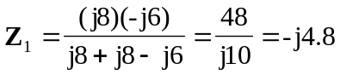
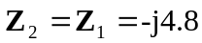
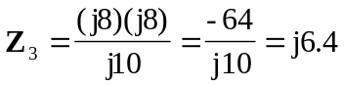

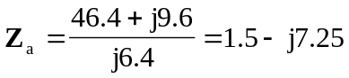
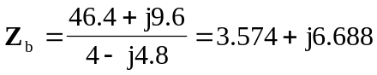
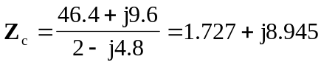

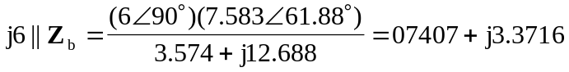
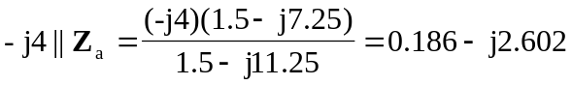
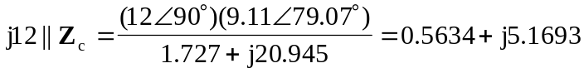

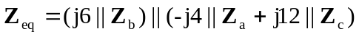
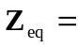 1.50875.42  = (0.3796 + j1.46) 

